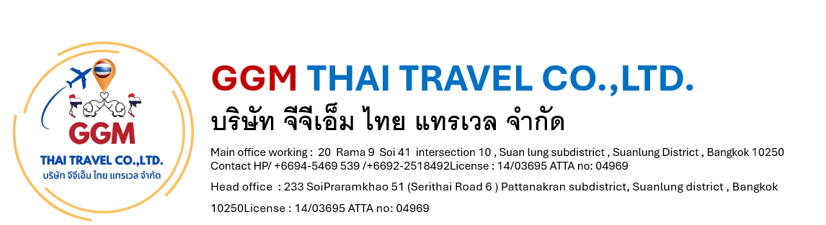
One day trip Coral island by speed boat

Pattaya Coral Island (Koh Larn) – Speed Boat Program
With Own Water Sport Activities
Program Overview:
Enjoy a tropical escape to Coral Island (Koh Larn) by speed boat, just 20–45 minutes from Pattaya. The island is famous for its clear turquoise water, white sandy beaches, and exciting sea activities.

🚤 Tour Highlights
- Speed boat transfer from Pattaya to Coral Island
- Relax on beautiful beaches or explore the island
- Flexible own activity (pay on spot or pre-select package)
- Free time for swimming / sightseeing

🌊 Optional Water Sport Activities (Own Expense)
Guests can choose activities based on their preference:
- Parasailing (fly over the sea)
- Jet Ski
- Banana Boat
- Snorkeling / Glass-bottom boat
- Sea Walker (underwater walking)
👉 These activities are very popular and can be arranged individually or as a package on-site.

⏰ Suggested Timing
- 08:30 – Pick up from hotel
- 09:30 – Depart by speed boat
- 10:00 – Arrive Coral Island & start activities
- 12:30 – Lunch at island restaurant (optional)
- 15:30 – Return to Pattaya
- 16:30 – Back to hotel

